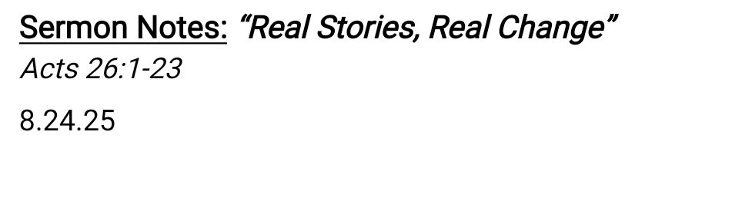

**BLESS Framework:**

* B - Begin with Prayer
* L - Listen with Care
* E - Eat Together
* S - Serve in Love
* **S - Share Your Story *(This week)***

**Lessons on sharing our real story about real change:**

1. Paul starts with Genuine Respect and Honor.
   1. When we honor people before sharing our story it shows we see them as valuable, not just targets for conversion.
2. Paul's "BEFORE" Credentials
   1. Paul isn't saying "I was bad, now I'm good”. He's saying this change is real, because he had everything to lose.
   2. Your credibility isn't perfection - it's authenticity about your real journey.
3. Don't hide your wrestling.
4. Being honest about our doubts and the mysteries of our faith isn't weakness - it's genuine. This reveals that authentic Christianity embraces questions, not just answers.
5. Paul’s “HOW” was not willpower it’s supernatural.
6. Paul’s “AFTER” revealed a new life mission and clear purpose.

**So What?**



**For Study, Reflection, Discussion:**

1. Review the sermon notes from Sunday. Was there a particular point that stuck with you? *What* was it and *why* did it resonate with you?
2. **Follow up:** How has it been going in trying to apply lessons from this series? *Example: Inviting someone to Church at the Lake, Applying B.L.E.S.S., seeing people the way Christ sees them, etc.*

**READ: Acts 26:1-23**

1. Paul honored King Agrippa before sharing his story (Acts 26:2-3). Think about someone you'd like to share your faith with. How could you genuinely honor them before sharing your story? What do you respect about their life or character?
2. The sermon talked about moving from “Mom and Dad’s faith” to “Owning your own faith” through wrestling with God. Have you experienced this transition? What questions or struggles helped your faith become more authentic and personal?
3. Not everyone has a dramatic “Paul” testimony - some have gradual “Timothy” stories. Which model better describes your journey? How can someone with a “quiet” story still powerfully share God's transformation in their life?
4. Paul's transformation led to a mission (Acts 26:19-20). How has your story with Jesus created a sense of mission in your life? Who specifically might God want you to share your story with?

**Deploy:**

**This week’s deployment:** This week, write out your story using the Before/How/After framework in exactly 3 minutes or less. Think aboutone aspect of your “before” that people in Wallowa County could relate to. Practice it until it feels natural and conversational. Then find ONE person from your prayer list and share it in normal conversation - not as a formal presentation, but as a natural part of relationship.

**Don’t Forget:**

* Aug 31st -- Church at the Lake
* September 7th: Life Groups and Sunday School Launching!!

**Prayer:**

Lord Jesus,

Thank You that our stories matter to You - not because they're perfect, but because they're real. Help us remember that every transformation in our lives comes from You, not from our own strength. Give us courage to share our authentic journey and help us honor the people You've placed in our lives. Show us how to naturally share what You've done for us.

Remind us that You get the glory in our stories - You're the hero, not us. Give us hearts that overflow with Your love, so sharing our story feels natural, not forced.

In Jesus name, Amen.